# **Task – 3**

Question-: Perform a Basic Vulnerability Scan on Your PC?

Solution-

1. **Go to the Official Nessus Website**:  
   https://www.tenable.com/products/nessus/nessus-essentials
2. **Register for Free**:
   * Click **“Get Started”** or **“Get Nessus Essentials”**.
   * Fill in your name and email address.
   * Agree to the terms and click **Submit**.
3. **Check Your Email**:
   * You’ll receive an email from Tenable with your **activation code**.
   * My code looks like this: 5XBS-UY88-GKFH-57K6-3TVX
4. **Enter It During Setup**:
   * When you install Nessus and open the web interface (usually at https://localhost:8834), it will prompt you to enter the activation code.
   * Paste the code from your email to continue.

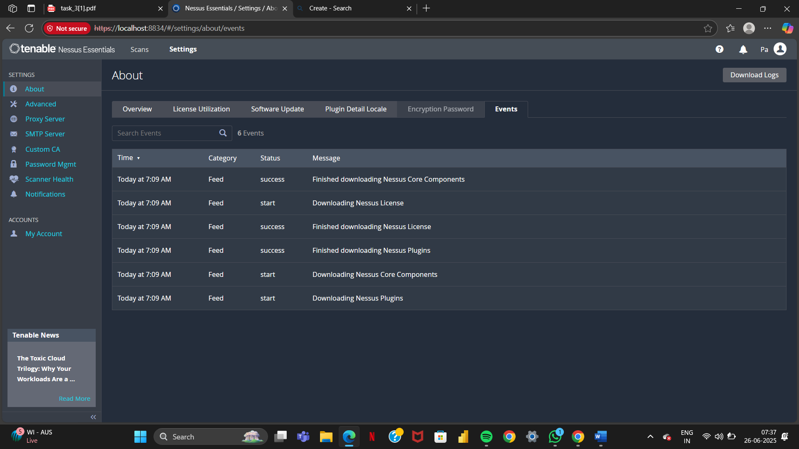

**Scanning Result-**

